TASK WEEK 1

P1 - Exhaustive Analysis of Indian Agriculture using Power BI

FROM

**PAL SATYAM GYANCHAND**

**AICTE Student ID: STU666efaad6524b1718549165**

Step 1:

Download Power BI desktop from Microsoft official website and install in device.

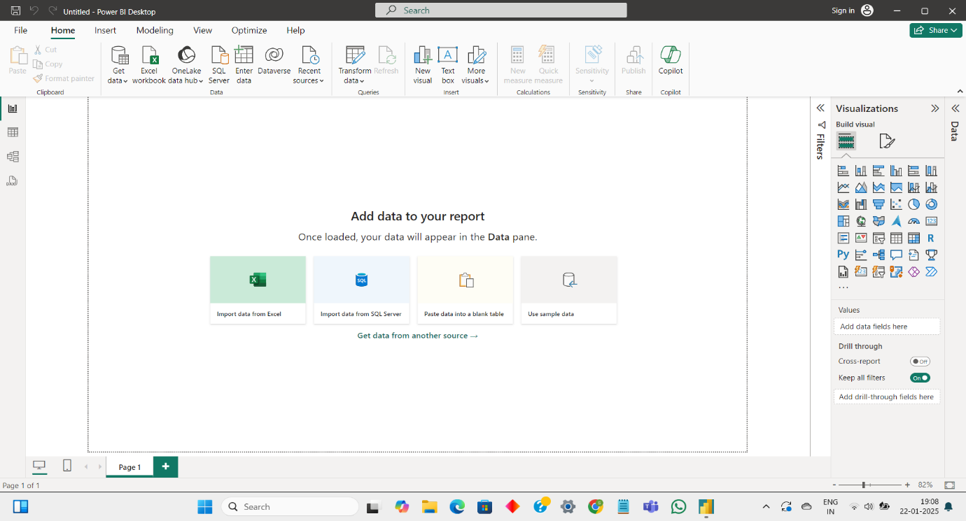

Step 2:

Open Power BI Desktop and open the Exhaustive Analysis of Indian Agriculture.csv file.

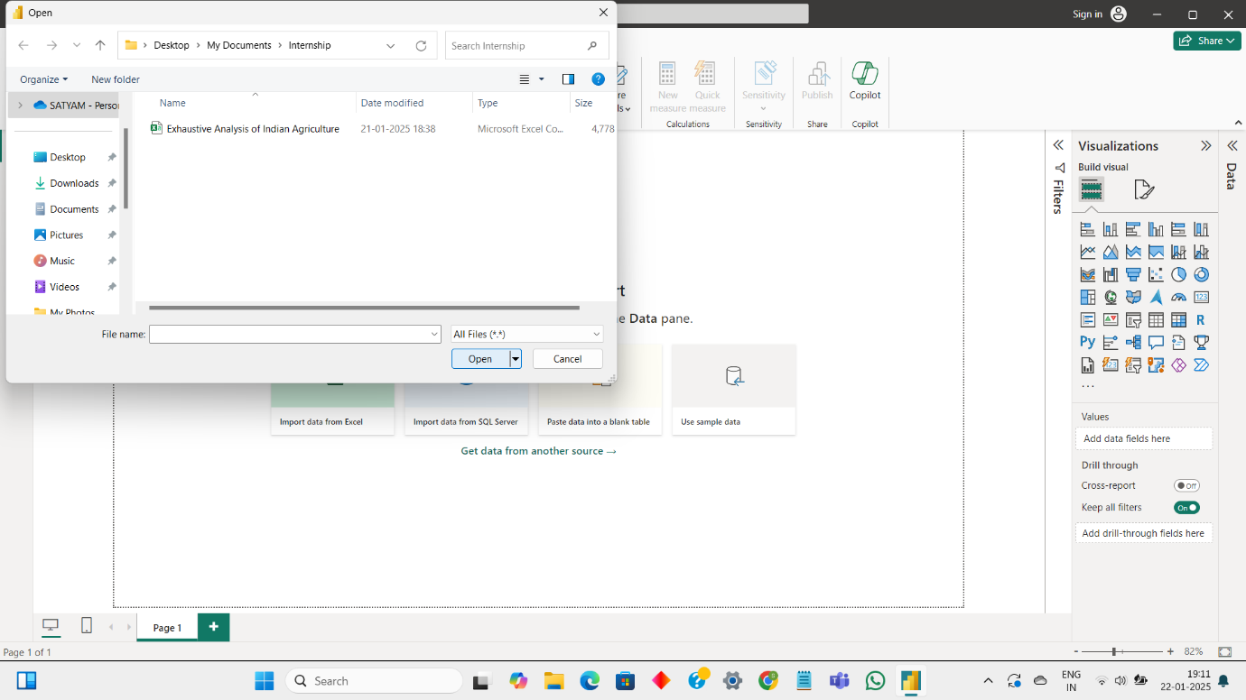

Step 3:

After that click on data load button.

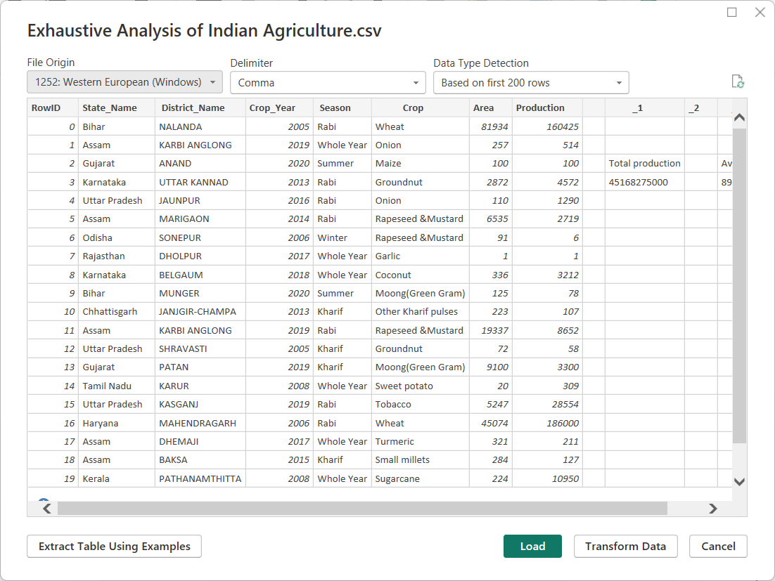

Step 4:

Click on the Transform Data button and in that there are so many options to transform data.

In our data there are so many unwanted columns. So we have remove them as per clean data process.

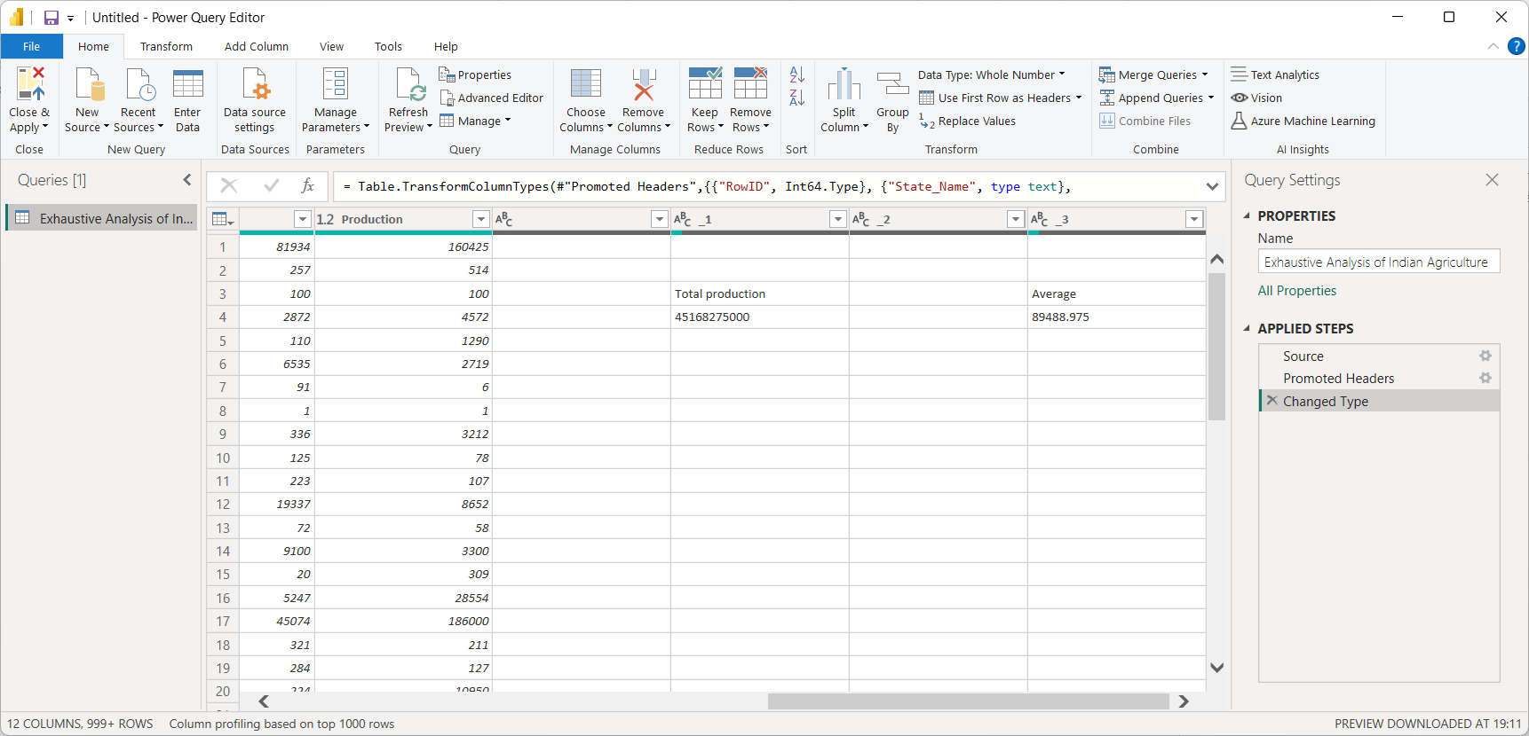

Step 5:

After removing unwanted columns in data we have clear data. Before proceeding further click on Apply & Close button. So our all process being saved.

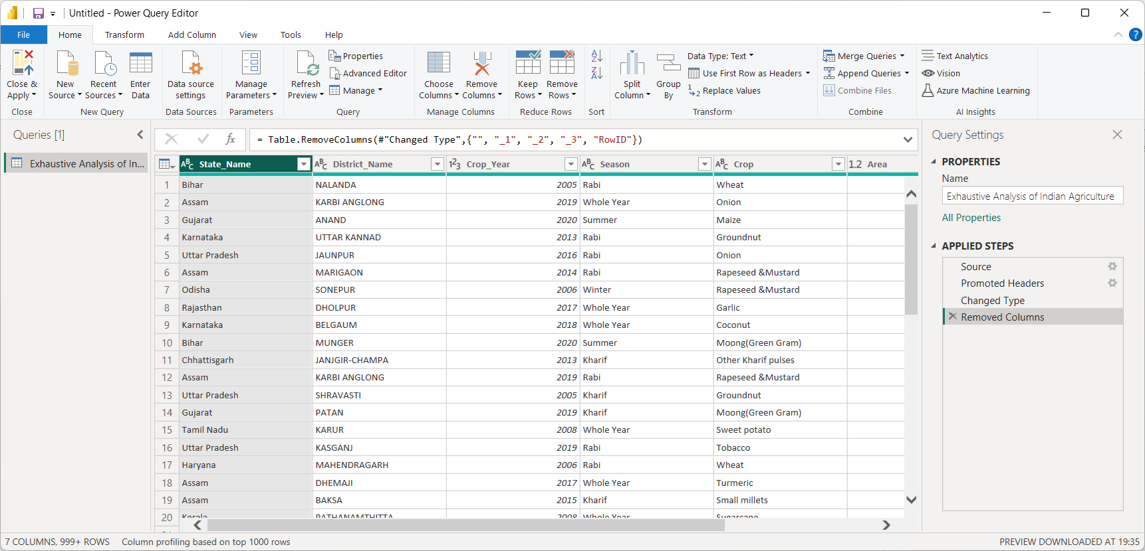

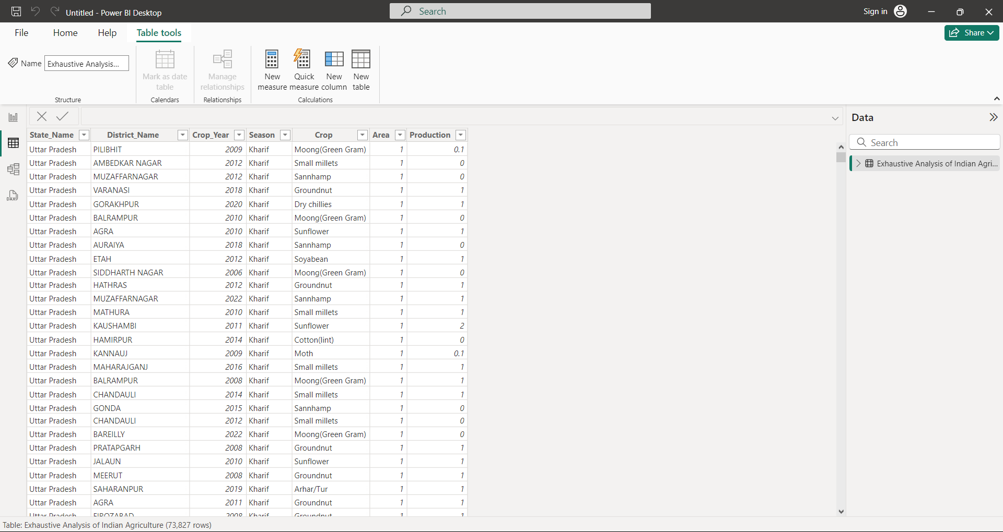

This is the task of week 1. It basically to clean data before working on it.

Your Sincerely,

**PAL SATYAM GYANCHAND**

**AICTE Student ID: STU666efaad6524b1718549165**